**Design Document for**

**Total Dominance**

All work Copyright ©2013 by Motion 9 Studios LLC

Written by Fathima Thotathil

Version # 2.0

Table of Contents

Contents

Design History 3

Game Overview 4

Introduction 4

Objective of the game 4

Genre 4

Target Audience 4

Look and Feel 4

Game Modes 5

Game Views 5

Game Rules 5

Phase one: placing pieces 6

Phase two: moving pieces 12

Strategy 15

Game Flow 15

Scoring System 24

Source of Revenue 25

Inapp purchase 25

# Design History

|  |  |  |  |
| --- | --- | --- | --- |
| Date | Version History | Remarks | By |
| 3/20/2013 | 1.0 | Initial Version | Fathima Thotathil |
| 3/26/2013 | 1.1 | Tossing coin, Help, Achievements, Menu Changes, Online Battle with Facebook friends, Twitter friends, ACW friends,(depending upon budget) random opponents using game center | Fathima Thotathil |
| 4/18/2013 | 1.2 |  | Fathima Thotathil |
| 5/12/2013 | 1.3 | Included Scoring System and Inapp purchase | Fathima Thotathil |
| 6/15/2013 | 2.0 | Updated Online Battle features, included in game notifications | Fathima Thotathil |

# Game Overview

## Introduction

This game is based on the [strategy](http://en.wikipedia.org/wiki/Abstract_strategy_game) [board game](http://en.wikipedia.org/wiki/Board_games) for two players called ‘Six Men Morris’ that was popular in Italy, France and England during the Middle ages but was obsolete by 1600.

## Objective of the game

The game is set on the background of the American Civil War fought between the Confederates and the Union from 1861 to 1865. Soldiers from both the groups replace the coins that were used in the original board game.

## Genre

Games – Strategy

## Target Audience

iOS users – 8+

## Look and Feel

The game screen should like as shown in the below figure.

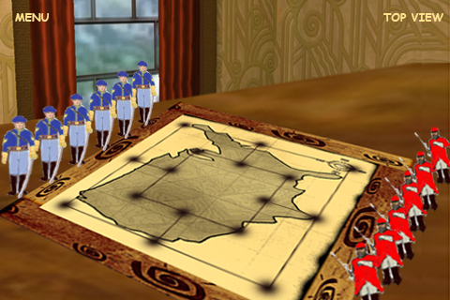

Switch to Top View

Navigates to Menu Page

Figure Normal View - Game Screen

# Game Modes

1) **Practice with AI** –Player plays against a simple AI to get the feel of the game.

2) **Online Battle** – It will be real time turn based multiplayer game with friends from either of the following:

1. Random opponents using the match making service from Game Center.
2. Friends in Game Center

# Game Views

1) **Normal View** – Sample shown in Figure 1 above.

2) **Top View** – Sample shown below in Figure 2.

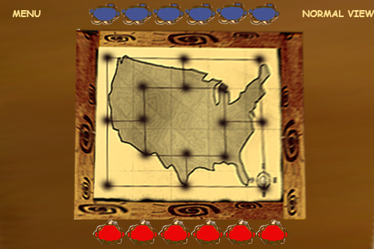

Navigates to the Menu Screen

Navigates to the Normal View

Figure Top View

# Game Rules

The board consists of a grid with 16 intersections or points. Each player has six soldiers. Players try to form 'mills'— three of their own men lined horizontally or vertically—allowing a player to remove an opponent's soldier from the game. A player wins by reducing the opponent to two soldiers, or by leaving him without a legal move.

The game proceeds in two phases (Not including the optional phase of moving men to any vacant point when a player has been reduced to three men):

1. Placing soldiers on vacant points
2. Moving soldiers to adjacent points

## Phase one: placing pieces

The game begins with an empty board and the soldiers lined up as shown below in Figure 3.



Figure Initially, before the play begins

## Which player starts the game?

1. **Player Vs AI**

Toss a coin to start the game. The player is given an option to choose head or tail. In a practice game, the player will be given the option directly to choose whether head or tail. While in multi player game, the player that initiates the match will get the first chance to choose head or tail as shown in Figure 4.

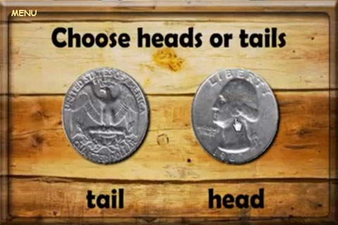

Figure Toss coin

In practice mode, the player chooses head or tail and then tossing of coin is displayed as shown in the following video (0:00 to 0:06)

<http://www.youtube.com/watch?v=LEUopVQxFUM>

If the player chooses head and he wins the toss, then

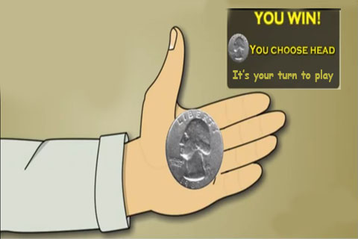

Figure Win Toss

If the player chooses head and he loses the toss, then

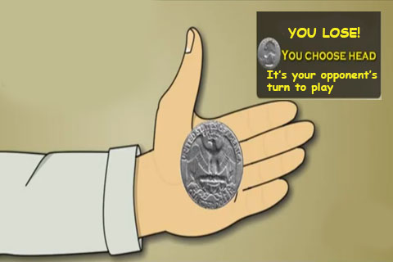

Figure Lose Toss

Based on who wins the toss, the match begins. The player and the AI then take turns placing their men one per play on empty points as shown in Figure 7.

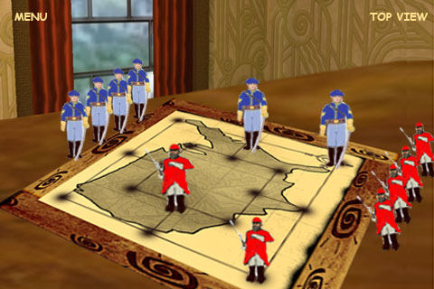

Figure Placing men on empty points – Union soldiers are trying to form a mill

1. **Online Multiplayer**
2. Randomly selected opponents – The player who starts the game will be randomly selected.
3. Match between friends – The player who initiates the game will start the game.

## Forming a mill

If a player is able to place three of his pieces in a straight line, vertically or horizontally, he has formed a mill and may remove one of his opponent's pieces from the board and the game. Any piece can be chosen for the removal, but a piece not in an opponent's mill must be selected, if possible.

A Mill can be formed in the following eight ways:

1. **Mill 1**

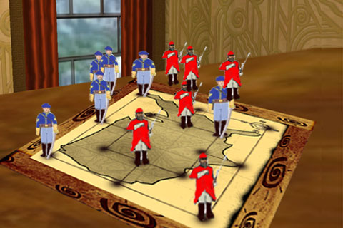

Any of the opponent’s soldiers which is not part of a mill can be removed

A Mill formed by the Union soldiers

Figure Mill formed vertically in the outer square

1. **Mill 2**

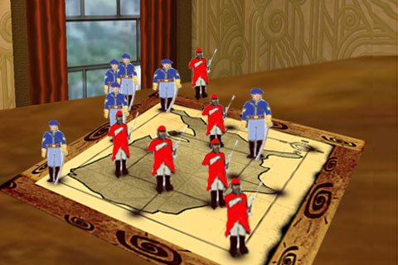

None of the soldiers in this mill can be removed.

Only this Union soldier can be removed.

A Mill formed by the Confederate soldiers

Figure Mill formed horizontally in the inner square

1. **Mill 3**

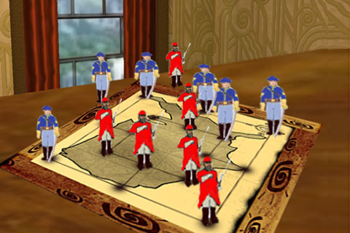

Only one of these soldiers can be removed.

These soldiers cannot be removed as they form a mill

A mill formed by the Union soldiers

Figure Mill formed horizontally in the outer square

1. **Mill 4**

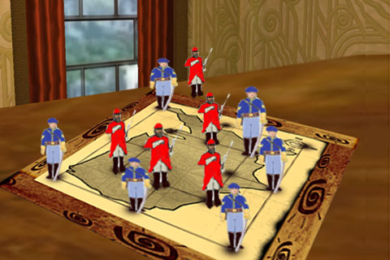

Only this soldier can be removed. The others form a mill.

A mill is formed by the union soldiers

Figure Mill formed horizontally in the outer square

1. **Mill 5**

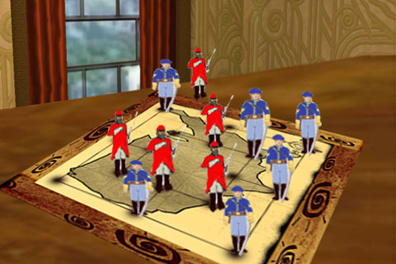

Only this soldier can be removed

A mill formed by the Union soldiers

Figure Mill formed vertically in the outer square

1. **Mill 6**

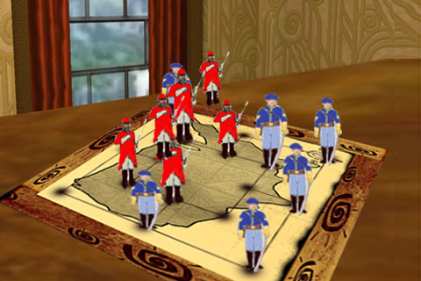

A mill is formed by the Confederate soldiers

Only any of these soldiers may be removed

Figure Mill formed vertically in the inner square

1. **Mill 7**

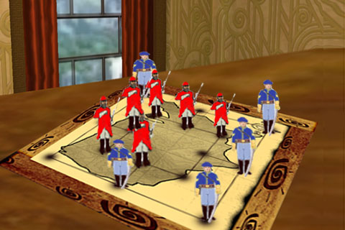

Any of these soldiers can be removed

A mill is formed by these soldiers

Figure Mill formed hrizontally in the inner square

1. **Mill 8**

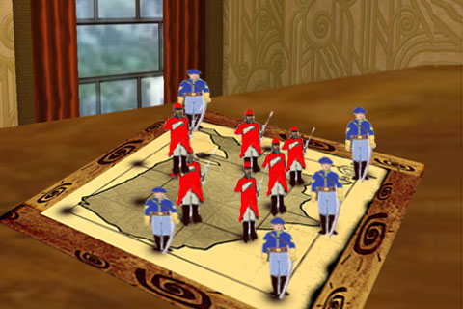

Any of these soldiers can be removed

A mill is formed by these soldiers

Figure Mill formed vertically in the inner square

Any piece can be chosen for the removal, but a piece not in an opponent's mill must be selected, if possible. Once all pieces have been placed, phase two begins.

## Phase two: moving pieces

Players continue to alternate moves, this time moving a man to an adjacent point. When moved, the soldier marches to the point tapped by the player as shown in the following figure.

**Animations by the soldier**

1. **Placing the soldier on the board from initial position** –To place the soldier at a desired point, player just taps the desired point. The soldier disappears from the initial formation position (figure 3 above) and appears at the point tapped by the player.

Animation by soldier – Soldier marches on the spot (Union and Confederate soldier) just once as shown in the following video -

<http://footage.shutterstock.com/clip-594916-stock-footage-soldier-in-military-boots-march-on-the-spot-close-up-profile.html>

Sound effect by soldier - Marching sound

1. **Moving the soldier to desired point -**To move the soldier to a desired point, player just taps the desired point. The soldier then marches towards the point.

Animation by soldier – Marching

Sound effect - Marching

## Other rules to be noted

A piece may not "jump" another piece.

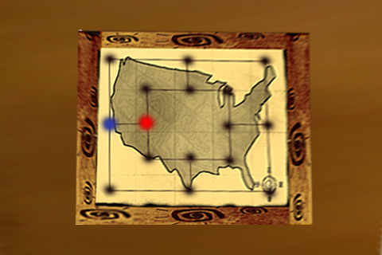

The confederate soldier can only move to the adjacent points which are not occupied.

Figure Moves allowed by Confederate Soldier

Players continue to try and form mills, and remove their opponent's pieces in the same manner as in phase one.

A player may "break" a mill by moving one of his pieces out of an existing mill, then moving the piece back to form the same mill a second time, or any number of times; and each time removing one of his opponent's men. The act of removing an opponent's man is sometimes called "pounding" the opponent.

For example: In the following figures, the confederate soldier breaks and forms a mill several times each time removing one of the union’s soldier.

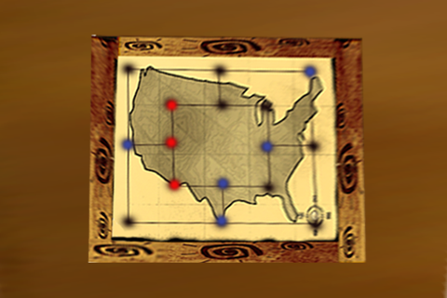

Confederate soldier forms a mill and one of the union soldiers is removed

Figure Confederate Soldier forms a mill

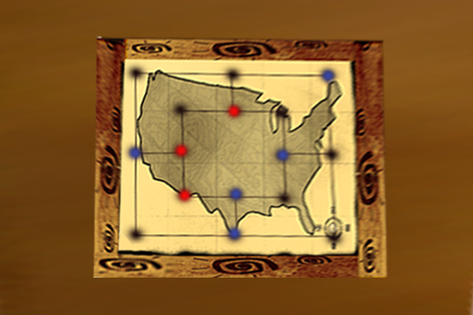

Confederate soldier breaks the mill

Figure Confederate soldier breaks a mill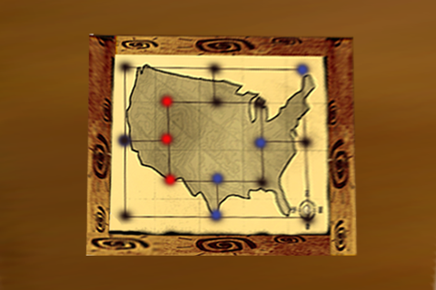

Union soldier is removed

Confederate soldier again forms the mill

Figure Confederate soldier again forms the same mill

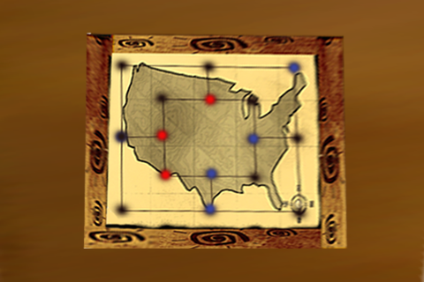

Confederate soldier again breaks the mill

Figure Confederate soldier again breaks the mill

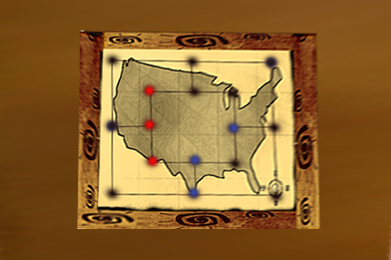

Union soldier is removed

Confederate soldier again forms the mill

Figure Confederate soldier again forms the mill

## Strategy

At the beginning of the game, it is more important to place pieces in versatile locations rather than to try to form mills immediately and make the mistake of concentrating one's pieces in one area of the board.

An ideal position, which typically results in a win, is to be able to shuttle one piece back and forth between two mills, removing a piece every turn (as shown in the figures 17 – 21).

# Game Flow

1. **Icon –** From the iPhone screen, the player clicks on the app icon. An idea on how the icon should look like:

* The Union Flag and Confederate Flag in the background and a soldier from each faction fighting. Sample as shown below.

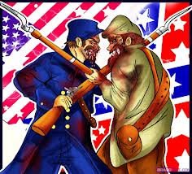

Figure 22 Icon Sample

1. **Name on the icon -** The name on the icon should be ‘TD’.
2. **Motion 9 Studios Splash screen -**



Figure Splash Screen (Already available with Larisa)

1. **Menu -** Menu in dropbox folder. The one in which credits icon, game center and sound icons are in the corners.
2. **Practice with AI –** The player plays the game against a simple AI.
3. **Choose your allegiance screen –** The player taps on one of the flags to select whether he wants to belong to the ‘Union’ or to the ‘Confederate’ faction.

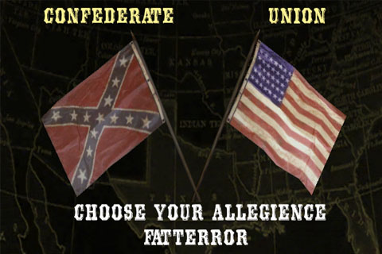

Figure Choose Your Allegiance screen

1. **Online Battle –** Only one game can be played at a time. Factions are assigned randomly. As soon as the user selects the multiplayer option, the following screen from Game Center opens up.

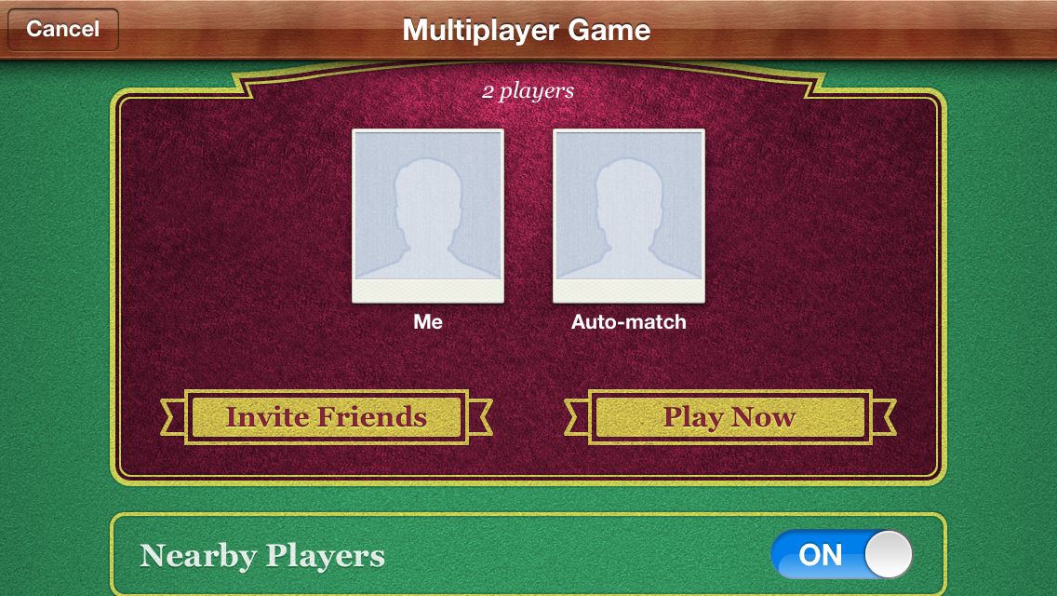

Figure Game Center Screen

The player plays against an opponent obtained in the following ways:

1. Random opponent (Game Center matchmaking) – Click ‘Play Now’ in the following screen to play with a random opponent. The user has the option to switch ON/OFF ‘Nearby Players.

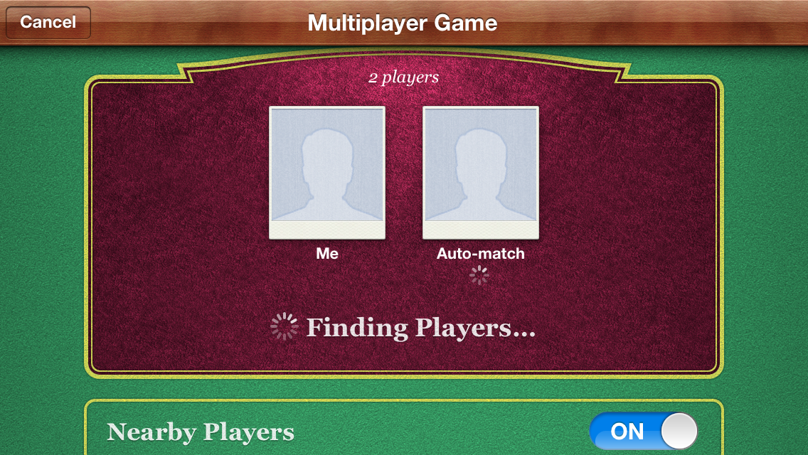

Figure Player selecting 'Play Now' option

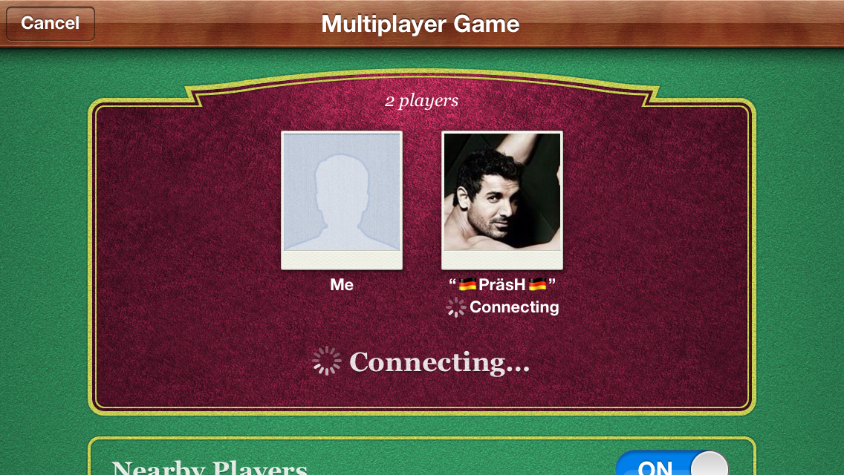

Figure Connecting to random opponent

Upon successfully finding a random opponent, the game screen opens up and the game begins.

1. Playing against Game Center friend – Click ‘Invite Friends to invite Game Center friends to play as opponent. The following screen opens up and displays the Game Center friend list.

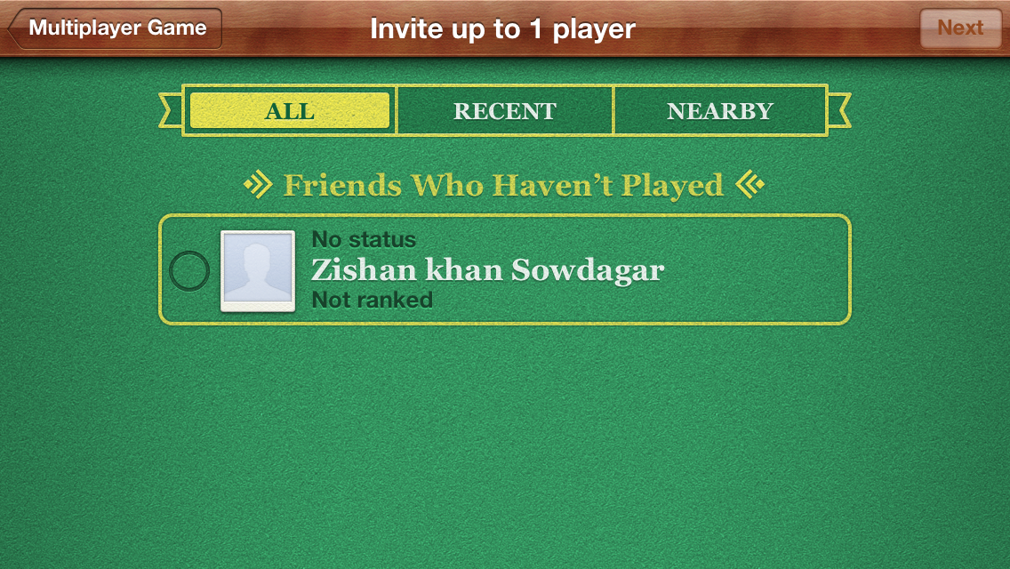

Figure Game Center Friend list

On clicking a friend, an invite can be sent inviting the friend to play an online match. It will say ‘Want to play Total Dominance – the turn based multiplayer strategy game that you have always been waiting for? The player can use the default message or may include optional personal message and click send to send invitation.

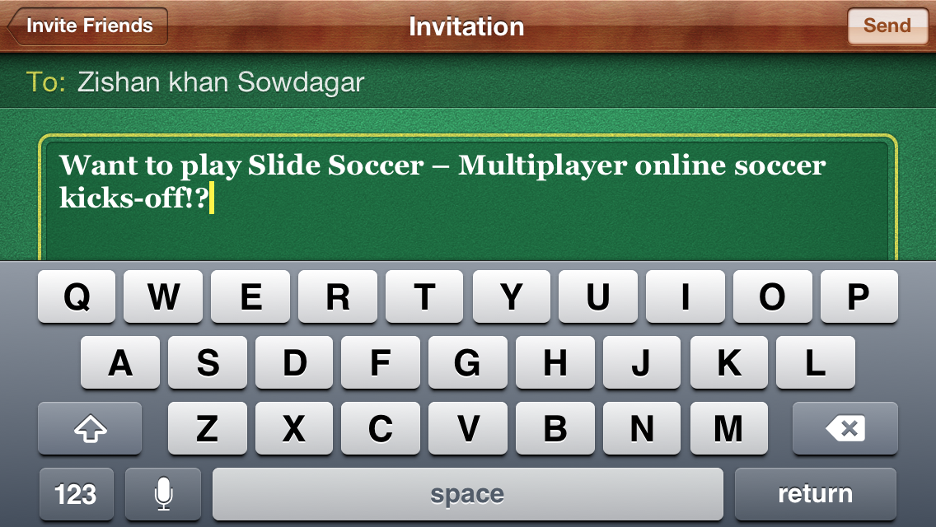

Figure Invitation

1. **Time limit for each turn by both the opponents –** Each opponent has a time limit (a variable say for now 30 seconds) to make his/her turn. This is implemented to keep the game exciting and interesting. If the player fails to make a move in the time limit, the following message should be displayed.

“Since you failed to make a move when it was your turn, you lose the game!”

In the opponent’s end, following message should be displayed.

“Since your opponent failed to make a move when it was his tune, you win the game!”.

1. **Leaving the Game –** The player may exit the game by clicking ‘Main Menu’. If player leaves the game before completing the game, the player loses the game.
2. **Notification of turns in game –** The faction which needs to play next should be highlighted. This will help the players to notify whose turn it is to play.
3. **Notification of opponent soldiers to be removed if player forms a mill –** The opponent soldiers which are qualified to be removed when a player forms a mill should start blinking until the player removes a soldier
4. **Help –** Animated help (TBD)
5. **Rate us –** The player is prompted to rate our game only when
6. The player has not rated the game earlier.
7. The player has won an online battle ( The reason behind this is there is a better chance for the player to give good ratings when the player is happy after winning a game)

Upon rating, the player wins an achievement and also receives a reward. (Will be explained in detail Achievements and rewards section).

Message Box – Rate us and become a Connoisseur!

1. **Like the Facebook Page –** The game will have a Facebook page of its own. The player is prompted to like our Facebook page only when
2. The player has not liked the page earlier.
3. The player has won an online battle ( The reason behind this is there is a better chance for the player to like the Facebook page when the player is happy after winning a game)

Upon doing so, the player wins an achievement and also receives a reward. (Will be explained in detail Achievements and rewards section).

Message Box – Rate us and become an Expert!

1. **Sound On/Off –** This button performs like a switch. It will turn on/off the sound as required by the player.
2. **Achievements –** On clicking the achievements icon on the Menu screen, the user navigates to the Achievements screen. Explained in detail in Scoring system section.

After completing an achievement, an overlay screen (sample below) should be displayed.



Navigate to the Menu Page

Depending upon budget

Instead of ‘Friendly’, display ‘Sociable’

Figure Sample Achievement awarding screen

1. **Game Center -** Achievements discussed above will be displayed on the app page in the game center. Leaderboard – Game center leaderboard.
2. **Credits –** An overlay screen like in Tesla Magic with the following details
3. Concept by Motion 9 Studios
4. Developed by Demst team
5. Art by Tuser Virgil
6. Motion 9 Studios Logo

# 

# Scoring System



**Overall score in Game Center is a sum of**

  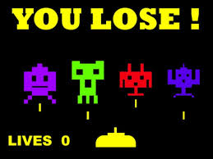 

**(a) (b) (c) (d)**

**(a) Points earned by winning each achievement – Explained in detail below**

**(b) Points earned after winning each game – 100 points**

**(c) Points earned after losing a game – 50 points**

**(d) Daily rewards (each day the customer uses the game) – 25 points**

**Points earned through achievement**

1. **Probationer –** When the player initiates to play the game for the first time, he earns this achievement. He wins 15 points.
2. **Novice –** After the player wins the first game, he earns this achievement. He wins 50 points.
3. **On Fire –** Every time the player wins five games consecutively on the same day, he wins 250 points. For eg. When the player first reaches this milestone, he earns this achievement and wins 250 points. After that every time, he wins five games consecutively (should be on the same day), he wins additional 250 points.
4. **Dominator –** Every time, the player plays 100 games, he wins 500 points. For eg. When the player first reaches this milestone, he earns this achievement and wins 500 points. After that every time, he plays additional 100 games, he wins additional 500 points.
5. **Conqueror –** Every time, the player wins 50 games, he wins 5000 points. For eg. When the player first reaches this milestone, he earns this achievement and wins 5000 points. After that every time, he wins additional 50 games, he wins additional 5000 points.
6. **Unsurpassable –** Every time, the player wins 10 times against the same opponent, he wins 1000 points. For eg. When the player first reaches this milestone, he earns this achievement and wins 1000 points. After that every time, he wins 10 times against the same opponent (maybe next time he wins against another opponent).
7. **Invincible -** Every time the player wins ten games consecutively (may not be on the same day), he wins 150 points. For eg. When the player first reaches this milestone, he earns this achievement and wins 150 points. After that every time, he wins ten games consecutively, he wins additional 150 points.
8. **Connoisseur –** After the player rates the game, the player wins 50 points and earns this achievement.
9. **Expert –** After the player likes the game facebook page and posts a winning strategy on the page and share it on his profile. The player wins 50 points.

# Source of Revenue

The main source of revenue for the game will be through ads. We will be using the following ad networks.

1. Admob banner ads will be displayed all the time at the lower part of the screen.
2. Chartboost pop up ads after the end of each game (practice and online).

# Inapp purchase

1. $0.99 – Double scoring points for a month
2. $0.99 – Remove Ads for a month